MEMBERSHIP IS FREE
Membership of the NHAG costs nothing, however being a member is valuable not only to you as an individual, but to the Nillumbik riding community as a whole. Your membership enables the NHAG to advocate as a representative body for local horse owners on all relevant matters of concern and interest.

MEMBER INFORMATION
Name/s (for family memberships)

Address: | Suburb: | P/code:
Postal Address (if different from residential address) | Suburb: | P/code:
Mobile: | Email:
Any skills you have that you feel might assist NHAG’s work:
Areas of equine interest and where we can assist you?
Declarations & Privacy:
I hereby apply for membership of the NILLUMBIK HORSE ACTION GROUP Inc.
I agree to abide by the Rules of the Incorporated Association as per the adopted Constitution.
I also acknowledge and agree to provide permission for photo/s of either my horse or myself being published on the club’s website or newsletter: Yes ( ) No ( )

Signed: Date:
PLEASE EMAIL FORMS TO: cathygiles@bigpond.com

See the website for more details: www.nhag.org.au
Nillumbik Horse Action Group | 0417 307 843 |
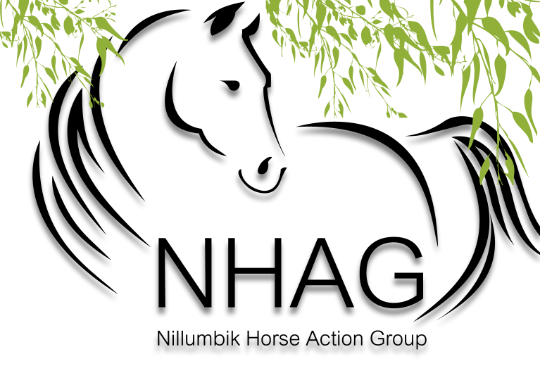
Membership Form 2021
ANNUAL MEMBERSHIP INCLUDES

- Supporting a recognised and respected equestrian entity to act on your behalf in liaison with Nillumbik Shire Council and other relevant authorities on all matters’ equestrian within Nillumbik Shire

- Connecting with like-minded individuals and organisations; exchanging information and ideas

- Receiving our email and e-newsletter updates

- Staying informed on local issues

membership form

