MEMBERSHIP FEES: INDIVIDUALS - $10 FAMILIES - $20
The Membership Fees assist in covering the basic running costs of the group, including annual incorporation, our website presence and general administration.
MEMBER INFORMATION
Name/s (for family memberships)

Address: | Suburb: | Postal Code:
Postal Address (if different from residential address) | Suburb: | Postal Code:
Mobile: | Home:
Any skills you have that you feel might assist NHAG’s work:
Areas of equine interest:
Declarations & Privacy:
I hereby apply for membership of the NILLUMBIK HORSE ACTION GROUP Inc.
I agree to abide by the Rules of the Incorporated Association as per the adopted Constitution
I also acknowledge and agree to provide permission for photo/s of either my horse or myself being published on the club’s website or newsletter:
Yes No

Signed: Date:
Payment:

I enclose (please tick ) $10.00 for an Individual Membership OR
I enclose (please tick ) $20.00 for a Family Membership

PLEASE MAKE CHEQUES PAYABLE TO:
Nillumbik Horse Action Group Inc.
MAIL FORMS AND PAYMENTS TO:
PO BOX 77
Smiths Gully VIC 3760

Fees may also be paid by Direct Debit - BSB: 633:108 Acc: 1457 54073
Please note “Mship” and your surname on receipt.
See the website for more details:
Nillumbik Horse Action Group | 0417 307 843 | www.nhag.org.au
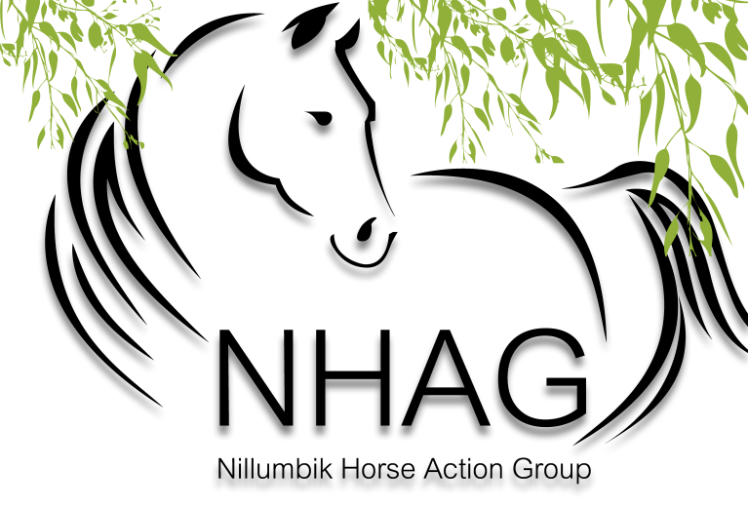
Membership Form 2012
ANNUAL MEMBERSHIP INCLUDES
- Supporting a recognised equestrian entity to act on your behalf in dealing with council on trail matters in your local area

- Connect with like-minded individuals and organisations; exchange information and ideas

- Receive our e-newsletter updates

- Stay informed on what is happening in ‘your backyard’

membership form

